NAC SME BF1

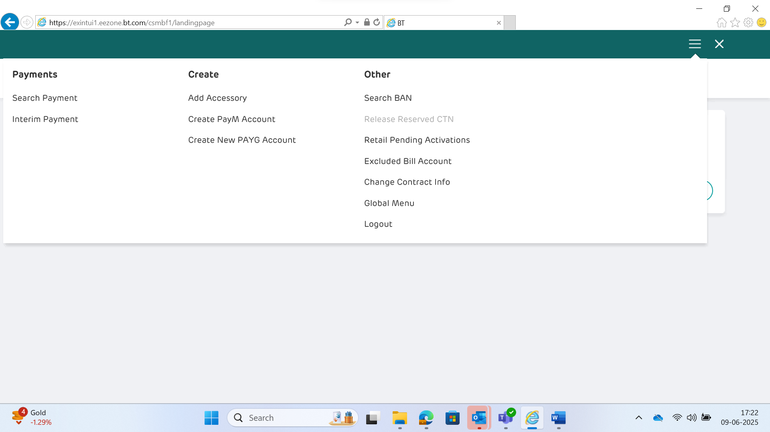

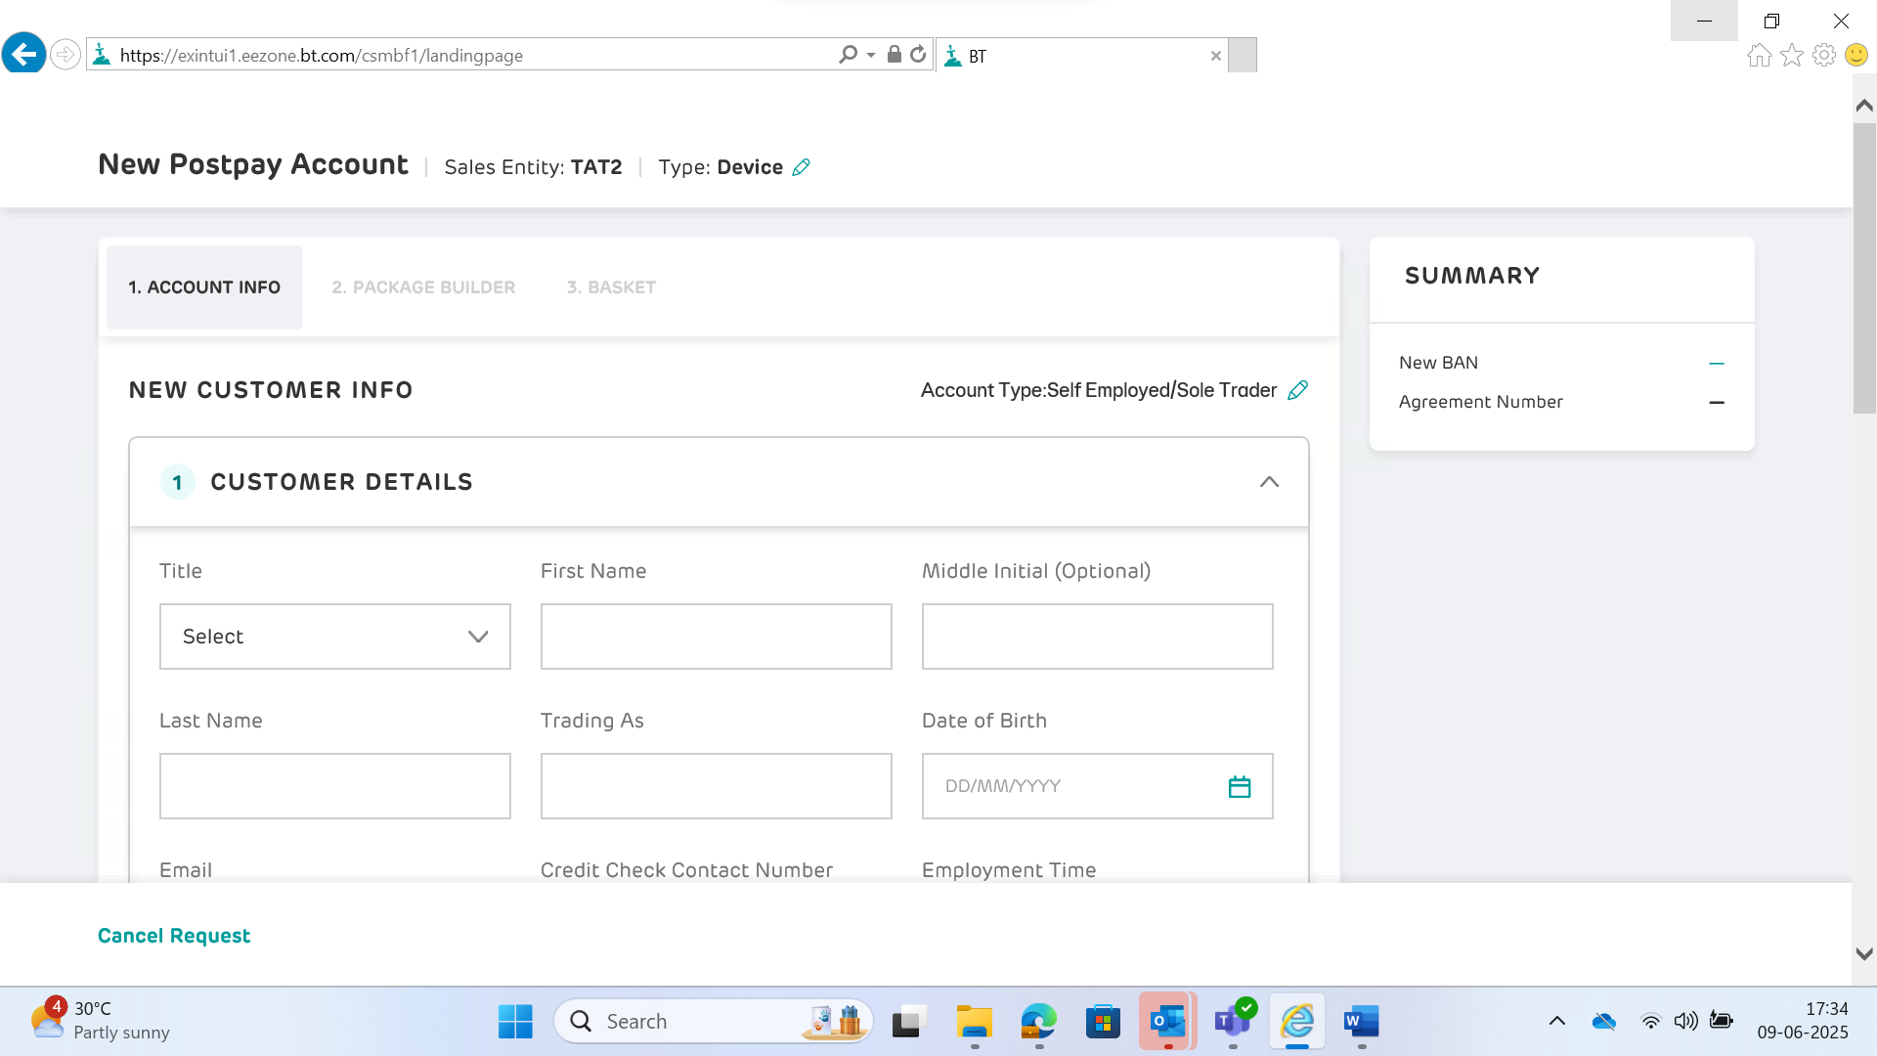

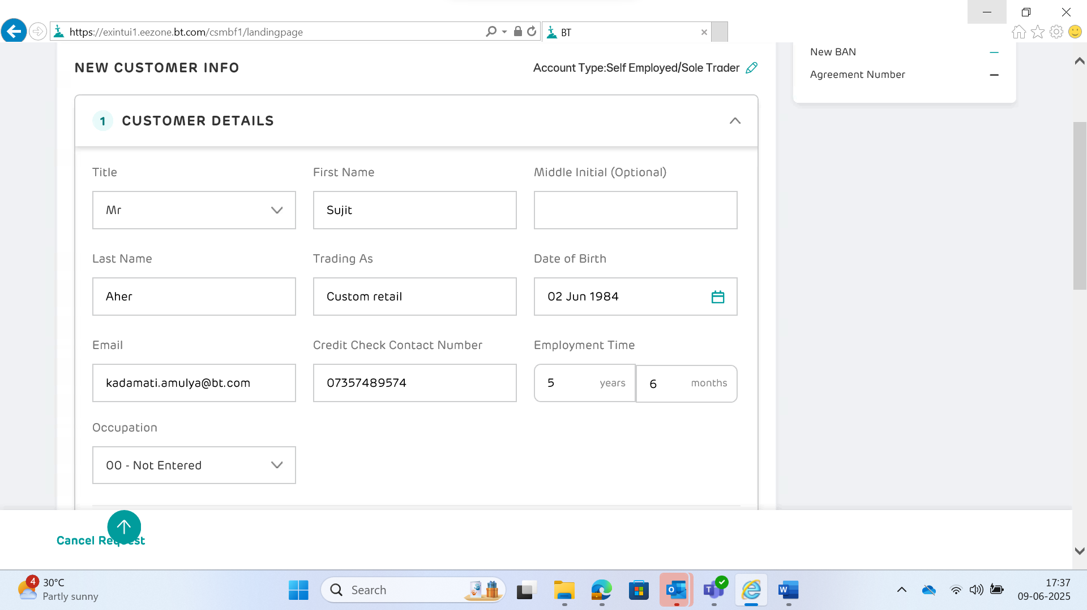

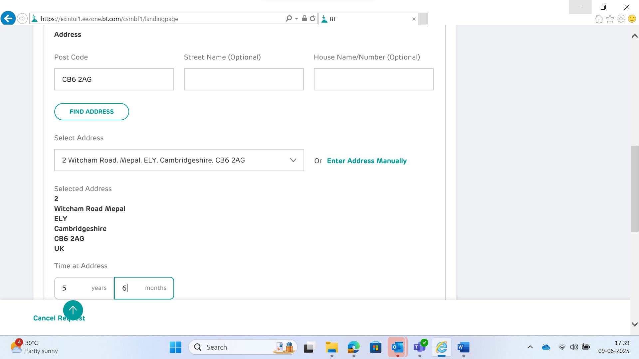

New BAN 204407750

Agreement Number 834617292



